Screenshots of tested scenarios:

1. <http://localhost:8888/producerConsumer/v1/createThreads/2/3> :

Here we have 2 producer threads and 3 consumer threads, that means counter will decrease more than increase, so Counter will decrease up to 0 and then we will terminate all thread.

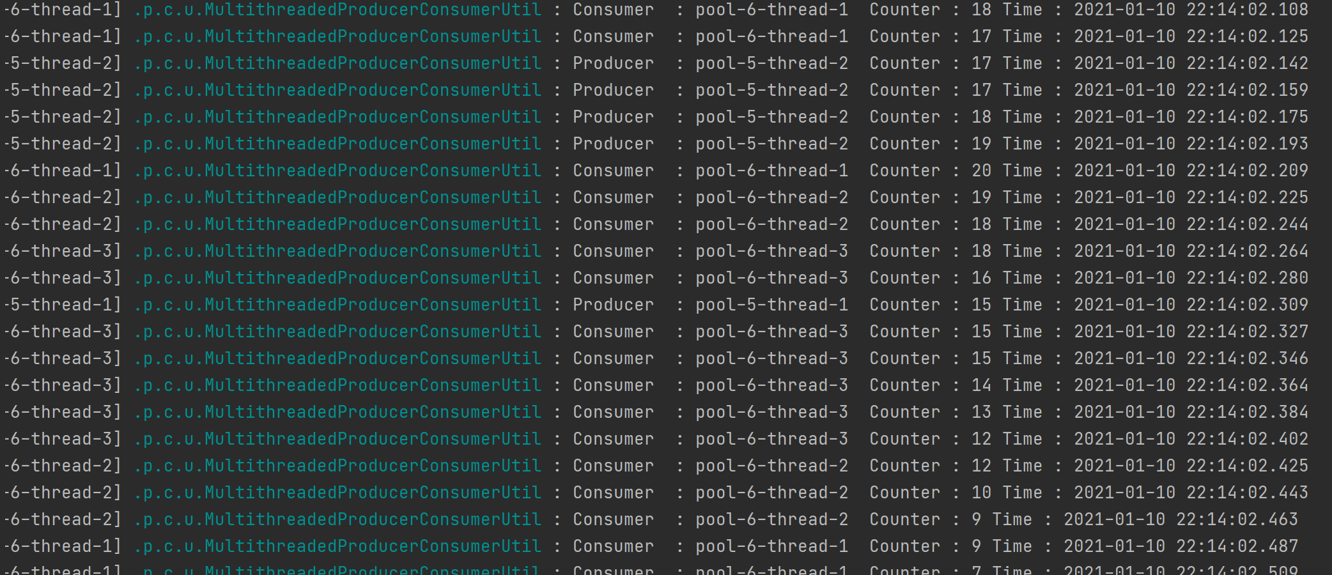

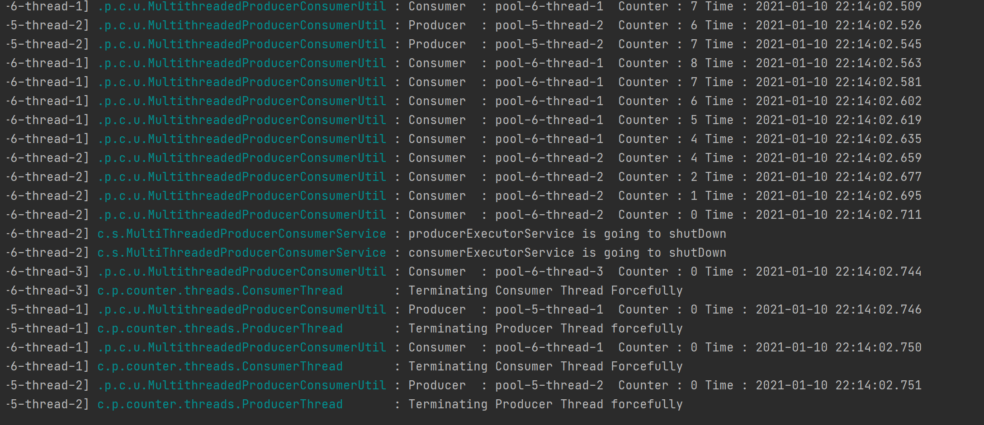

1. <http://localhost:8888/producerConsumer/v1/createThreads/3/2> :

Here we have 3 producer threads and 2 consumer threads, that means counter will increase more than decrease, so Counter will increase up to 100 and then we will terminate all threads.

